AI ASSIGNMENT-15
NAME:D.ANKITHA
ROLL NO:2503A51L09
Backend API Development: Creating RESTful services with AI
Lab Objectives:
Understand the fundamentals of RESTful API design.
Use AI-assisted coding tools to generate backend services.
Implement CRUD (Create, Read, Update, Delete) operations.
Document endpoints with comments and auto-generated documentation.

Task 1: Setup Flask Backend
Instructions:
Install Flask and set up a basic Python server.
Use AI to generate starter code for a simple backend with a single endpoint.
Legacy/Starter Code:
from flask import Flask, jsonify
app = Flask(__name__)
@app.route('/')
def home():
return jsonify({"message": "Welcome to AI-assisted API"})
if __name__ == "__main__":
app.run(debug=True)
Expected Output:
Running the server should show:
http://127.0.0.1:5000/
Accessing it in the browser or Postman returns:
{"message": "Welcome to AI-assisted API"}
Code:
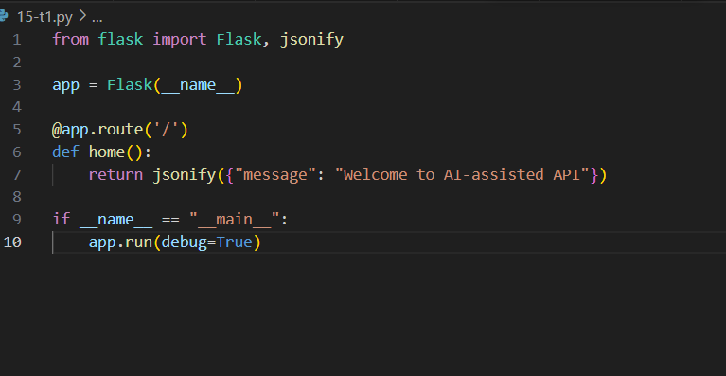
Output:
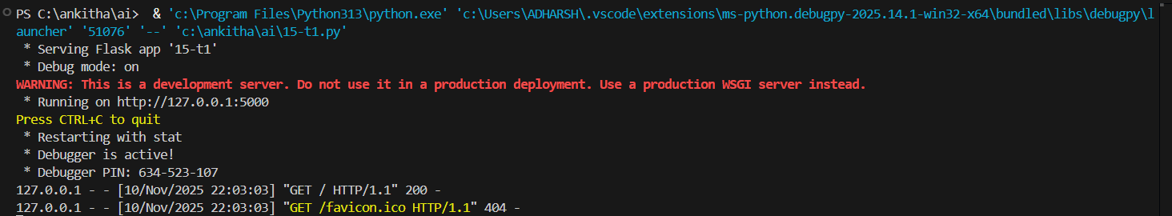
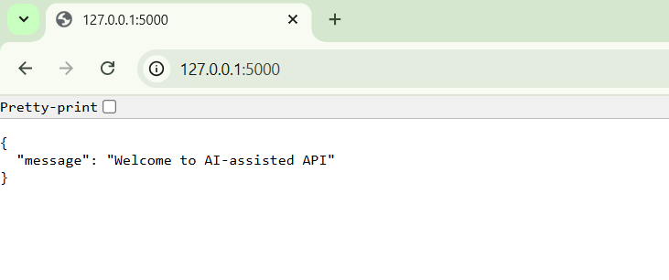
Observation:
Installation Simplicity: pip install flask is straightforward and reproducible across platforms.
- Minimal Code Footprint: The starter code is concise, making it ideal for beginners to grasp core concepts.
- Immediate Feedback Loop: Running the server and accessing http://127.0.0.1:5000/ provides instant validation of setup success.
- Clear Output: The JSON response {"message": "Welcome to AI-assisted API"} confirms endpoint functionality
Task 2: Create a CRUD API – Read and Create
Instructions:
Use AI to implement endpoints to list all items and add a new item.
Use an in-memory Python list to store items.
Starter Code:
from flask import Flask, jsonify, request
app = Flask(__name__)
items = []
# GET all items
@app.route('/items', methods=['GET'])
def get_items():
return jsonify(items)
# POST a new item
@app.route('/items', methods=['POST'])
def add_item():
data = request.get_json()
items.append(data)
return jsonify({"message": "Item added", "item": data}), 201
Expected Output:
GET /items → [] initially
POST /items with payload {"name":"Book","price":200} →
{"message": "Item added", "item": {"name":"Book","price":200}}
GET /items now returns:
[{"name":"Book","price":200}]
Code: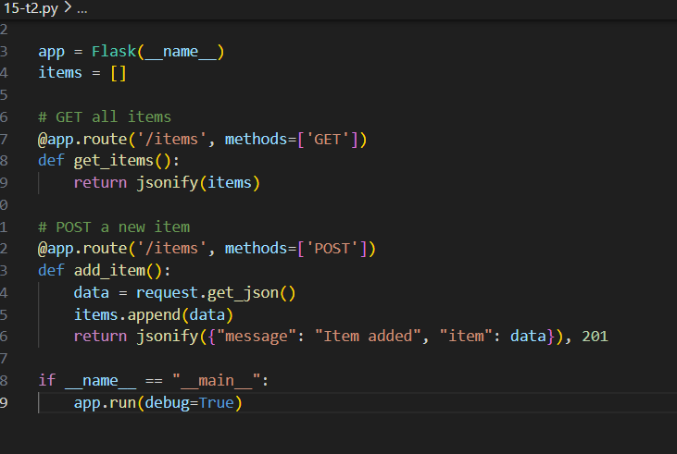
Output:
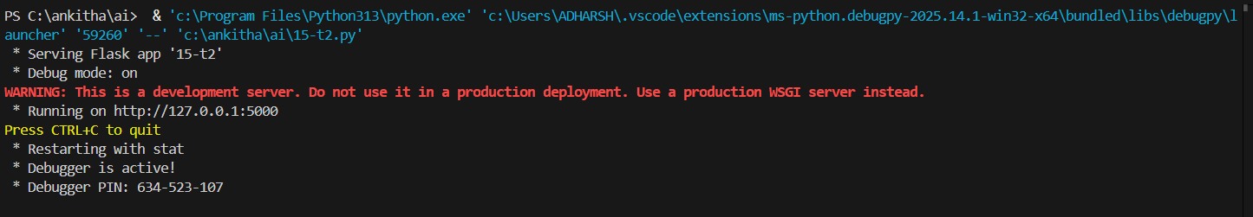
Observation:
In-Memory Storage: Using a list (items = []) keeps the logic simple and transparent for beginners.
- RESTful Design: Clear separation of GET and POST methods aligns with REST principles.
Immediate Feedback: Students can test with Postman or browser and see real-time changes.
Task 3: Update Item
Instructions:
Use AI to create a PUT endpoint to update an existing item based on its index or ID.
Starter Code:
# PUT /items/<int:index>
@app.route('/items/<int:index>', methods=['PUT'])
def update_item(index):
if index < 0 or index >= len(items):
return jsonify({"error": "Item not found"}), 404
data = request.get_json()
items[index] = data
return jsonify({"message": "Item updated", "item": data})
Expected Output:
PUT /items/0 with payload {"name":"Notebook","price":250} →
{"message": "Item updated", "item": {"name":"Notebook","price":250}}
Code: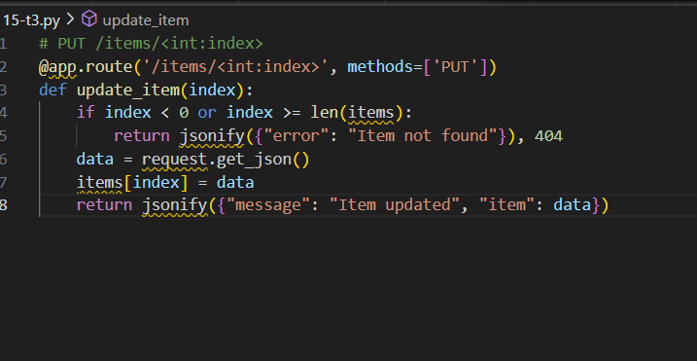
Observation:
Index-Based Routing: Simple and intuitive for students to grasp.
- Error Handling: Validates index bounds and returns 404 if out of range.
- Full Replacement Logic: Replaces the entire item with new data
Task 4: Delete Item
Instructions:
Use AI to create a DELETE endpoint to remove an item by index or ID.
Starter Code:
# DELETE /items/<int:index>
@app.route('/items/<int:index>', methods=['DELETE'])
def delete_item(index):
if index < 0 or index >= len(items):
return jsonify({"error": "Item not found"}), 404
removed_item = items.pop(index)
return jsonify({"message": "Item deleted", "item": removed_item})
Expected Output:
DELETE /items/0 →
{"message": "Item deleted", "item": {"name":"Notebook","price":250}}
GET /items → []
Code:
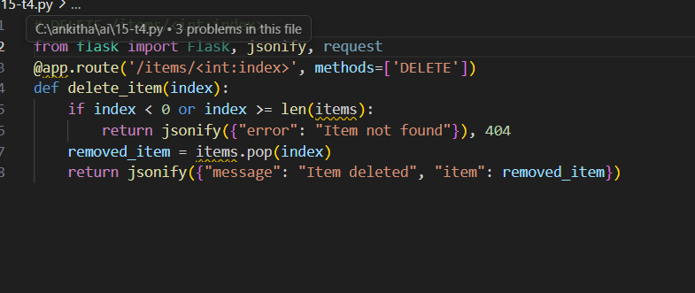
Observation:
Index-Based Routing: Simple and consistent with previous tasks.
- Error Handling: Prevents out-of-range deletions with a 404 response.
- Clear Feedback: Returns the deleted item for confirmation.

